Name
Course
Professor
Instituion
Date
Creative Responses

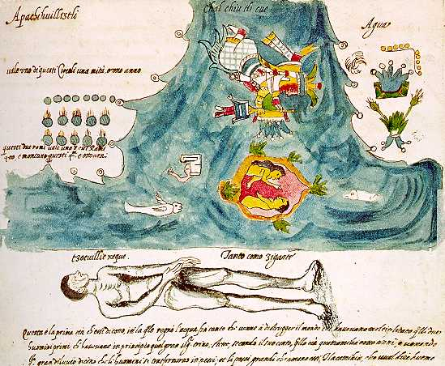
("Codex Vaticanus A, P. 4V.")
Rain
People were eagerly waiting for the rain.
They used to pray from mountains and hills day and night.
They offered sacrifices so that their prayers could be answered.
They went for a number of days without food although they only had little food.

Their prayers were later answered with a heavy downpour.
All the places turned green because of plenty water.
The weather changed due to heavy rain.
People put on heavy clothes to save them from cold.
They could light fire to warm themselves at night.

The rain also brought floods which was contrary to the prayers that were made.
The rivers broke their barks due to floods.
The seas and the lakes were filled to the brim.
The crops and vegetation were also destroyed.
Buildings were destroyed by the floods

People started looking for a shelter when the buildings were destroyed.
A certain couple went to the hill to save themselves from the floods.
They were lucky since the floods did not affect them.
The rest were destroyed by the floods because the land was covered with water.

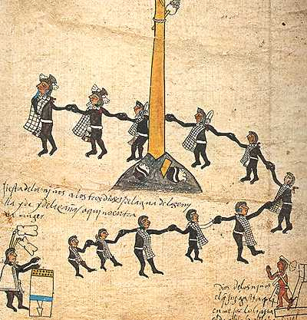
("Codex Borbonicus, P. 28. Detail")
Children
Children are blessings to the parents.
They are source of joy to the community.
They are communally owned such that everybody should take care of the children.
They are supposed to be protected by all members of the community.
They are seen as the wealth of a society.

They like being together while carrying out various activities.
They value unity among themselves as they interact.
They interact freely because they do not have grudge with each other.
They are good example to the adults because they do hate each other.
They like enjoying themselves during leisure time.

They take part in certain festivals in the society such as commemoration of certain events.
They entertain people during the ceremonies through use of dances.
They put on costumes when entertaining audience in a festival.
They using musical instruments that accompany the songs.
They have a leader who guides them during the entertainment.

Works cited
"Codex Borbonicus, P. 28. Detail". Library.Arizona.Edu, 2020,
http://www.library.arizona.edu/exhibits/mexcodex/borb28.htm.
"Codex Vaticanus A, P. 4V.". Library.Arizona.Edu, 2020,
http://www.library.arizona.edu/exhibits/mexcodex/vat04vd.htm.

